Sendgrid integration with python code

|  |  |
| --- | --- |
| TEAM ID | PNT2022TMID46979 |
| PROJECT NAME | SMART FASHION RECOMMENDER APPLICATION |
| DATE | 15/11/2022 |

1. Create an SendGrid Account.

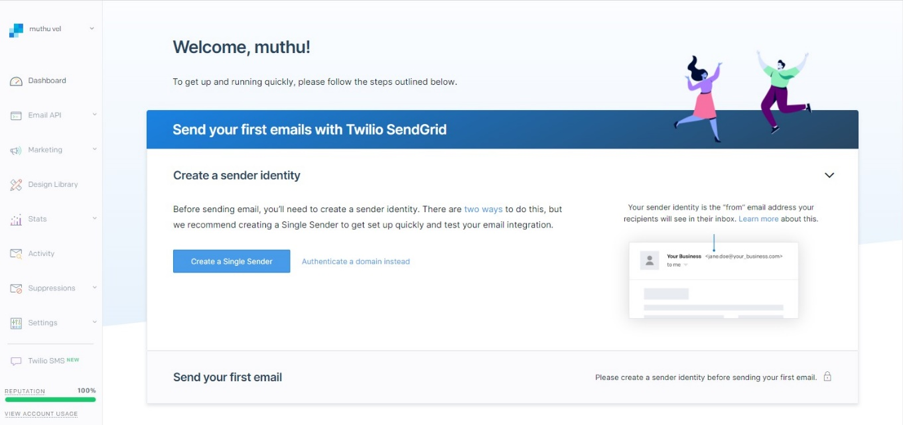

2.Code to Integrate SendGrid with Python

